

Hello, LinkedIn fam!

I'm thrilled to share a significant milestone in my professional journey. Coming from a non-IT background, I took a bold leap into the dynamic field of DevOps, and I couldn't be more proud of my accomplishments!

Over the past few months, I've invested my time and dedication to upskill myself in this rapidly evolving field. I recently completed a comprehensive beginners' course with Nana, a renowned DevOps expert. This course provided me with a solid foundation in various DevOps concepts and tools, empowering me to dive deeper into this fascinating domain.

But knowledge alone wasn't enough for me. I knew I needed hands-on experience to truly thrive in this field. So, I took on a challenging project that encompassed the entire Software Development Life Cycle (SDLC).

Today, I stand confidently, no longer defined by my non-IT background. I am equipped with the skills and mindset required to tackle complex challenges in the DevOps space. My passion for automation, scalability, and optimizing software development processes has found its perfect home.

Let’s start!

**My First Project**

Name: Saba Usman

Project Title: SDLC

Procedure; Shared step by step

**About app and its stages;**

The app development lifecycle, also known as the software development lifecycle (SDLC), is a structured process that outlines the various stages involved in developing a software application.

**Developing and deploying an app from scratch.**

* Analysis and Planning.
* Fronted

Front-end;

I have utilized the Vue.js JavaScript framework to develop the frontend of my app. In my opinion, Vue.js is an ideal choice due to its lightweight nature and its ability to handle complex website development efficiently.

By leveraging Vue.js, I can seamlessly combine HTML, CSS, and JavaScript within a single platform, which simplifies the development process. This framework empowers me to handle intricate coding requirements with ease.

Overall, Vue.js has proven to be a valuable tool in creating the frontend of my app, allowing for a streamlined and efficient development experience. Some SS of my work:

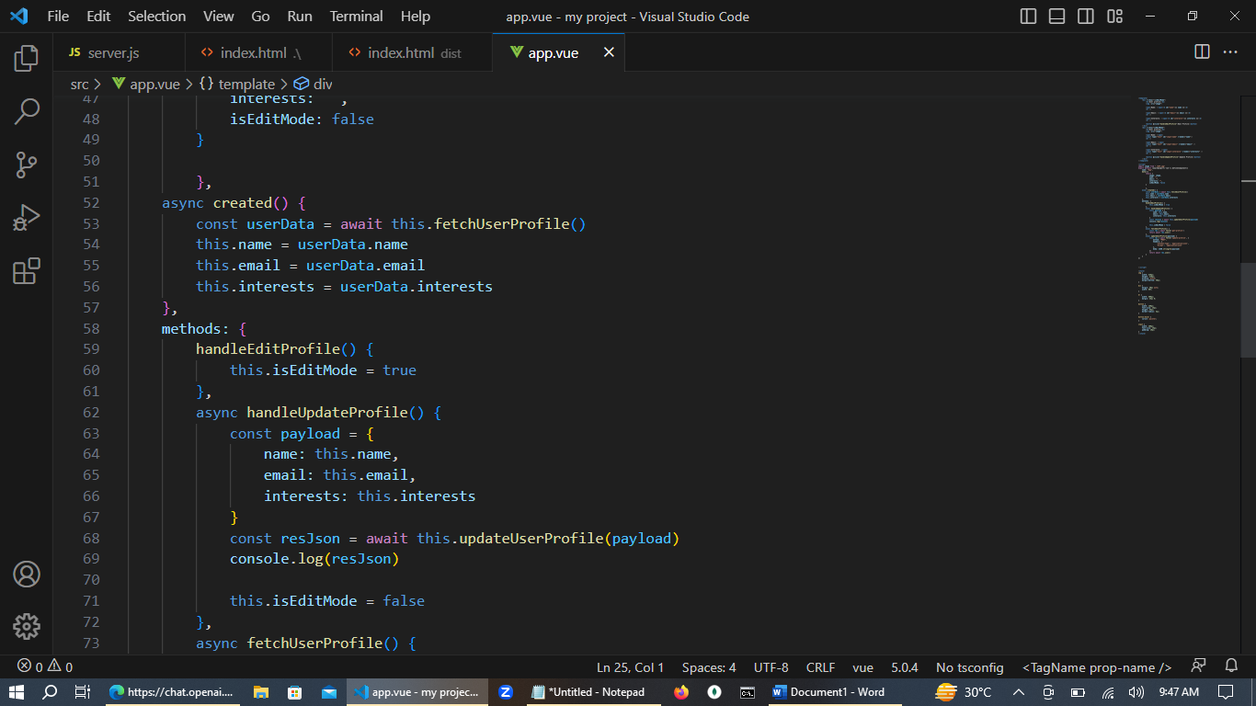

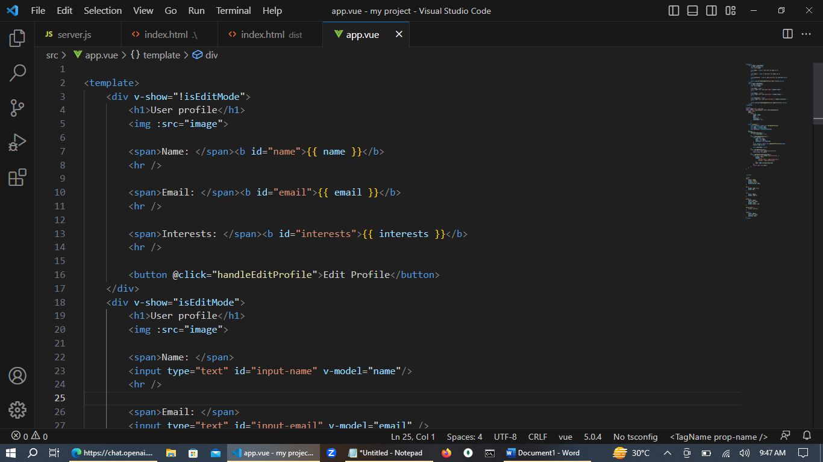

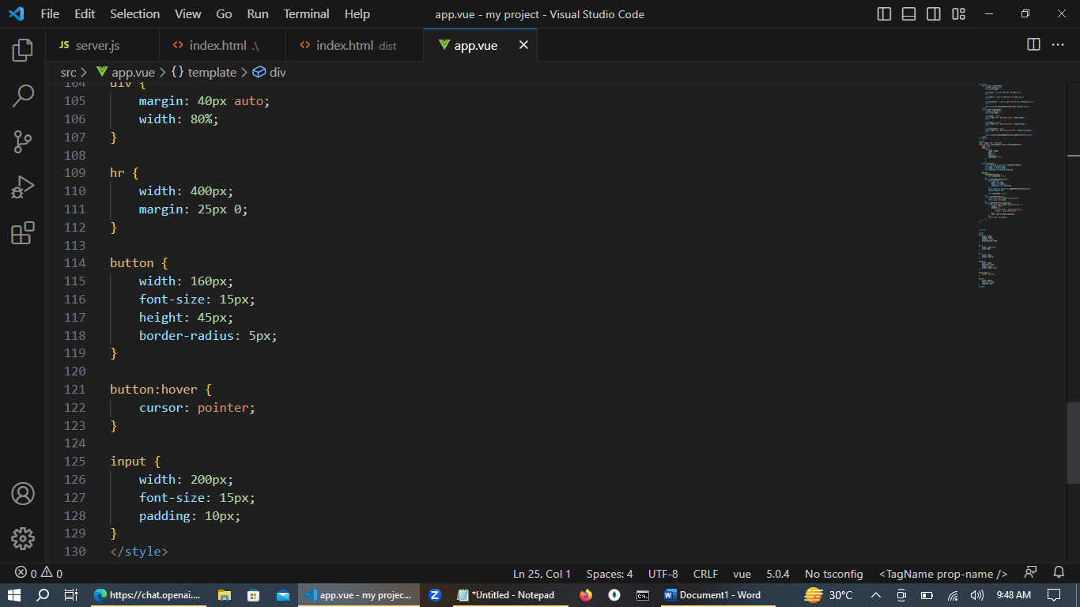

***Essential Dependencies for Vue app:***

1. **Vue**
2. **Core-JS; Ensure that JS code works on all browsers and browser versions**
3. **Compiler; Compile vue.js to vanilla JS**
4. **Cli-service; Providing Vue.JS CLI commands build, server**

**Important.**

**For install above dependencies am using command “npm install” on terminal in visual studio. This command reads the package.json file and installs all the required dependencies listed in the dependencies section. Tis command also used to update packages in node modules.**

*Build process:*

Before the local server starts, command “npm run serve” often triggers a build process. The build process could involve transpiling, bundling, and optimizing the source code. This step ensures that the web application is ready to be served and that any necessary transformations have been applied.

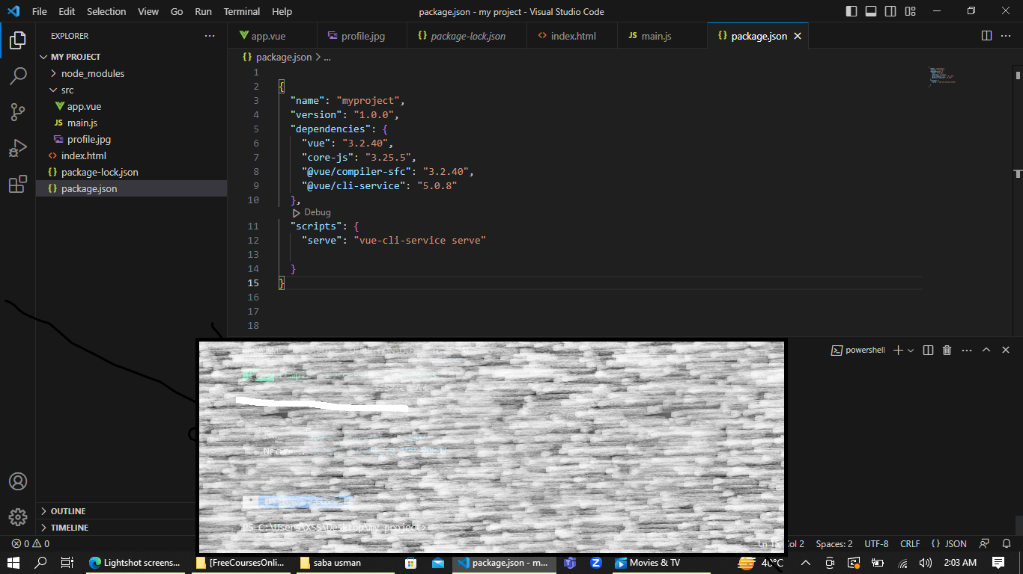

Necessary Dependencies for front-ed

After the build process is complete, the command launches a local development server. This server hosts the compiled web application and makes it accessible through a specific/standrad URL (e.g., <http://localhost:3000>).

It's important to note that the behavior of “**npm run serve”** can be customized based on the project's needs. The configuration can be found in the **scripts** section of the **package.json** file.

After essential dependencies installed & coding am using command “npm run serve” for compile my application. Before the local server starts, npm run serve often triggers a build process. The build process could involve transpiling, bundling, and optimizing the source code. This step ensures that the web application is ready to be served and that any necessary transformations have been applied.

So yes my app compiled successfully and running at: http//localhost:8080/

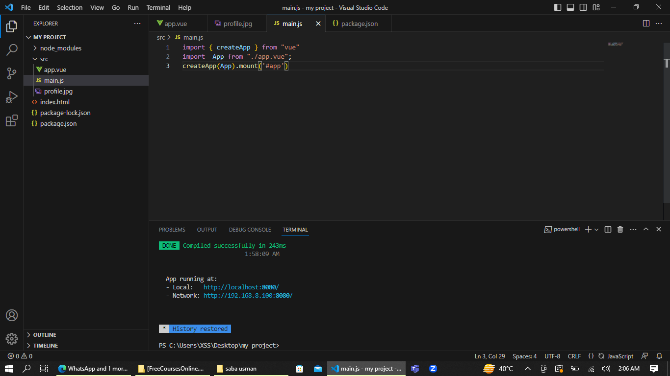

Now its time to start my application so for this purpose am using command “npm run start”. And finally my fronted is ready to go on browser (localhost:3000).

It's important to note that the specific behavior of “**npm run start”** can be customized based on the project's requirements. The configuration for “**npm run start”** can be found in the **scripts** section of the **package.json** file, where you can define the command or script to be executed.

**"I am excited to share a few screenshots that capture the result of my dedicated efforts. It feels incredibly fulfilling, as if my dreams have become a reality."**

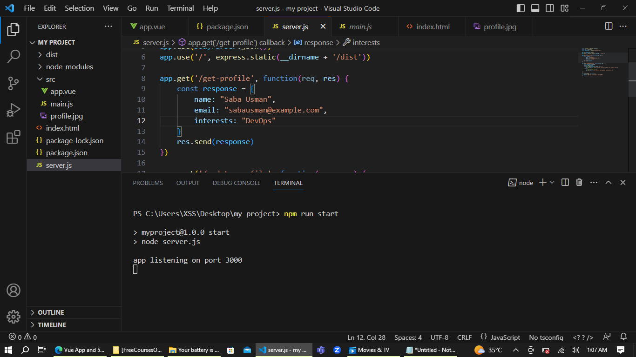

**Finally my fronted is ready:**

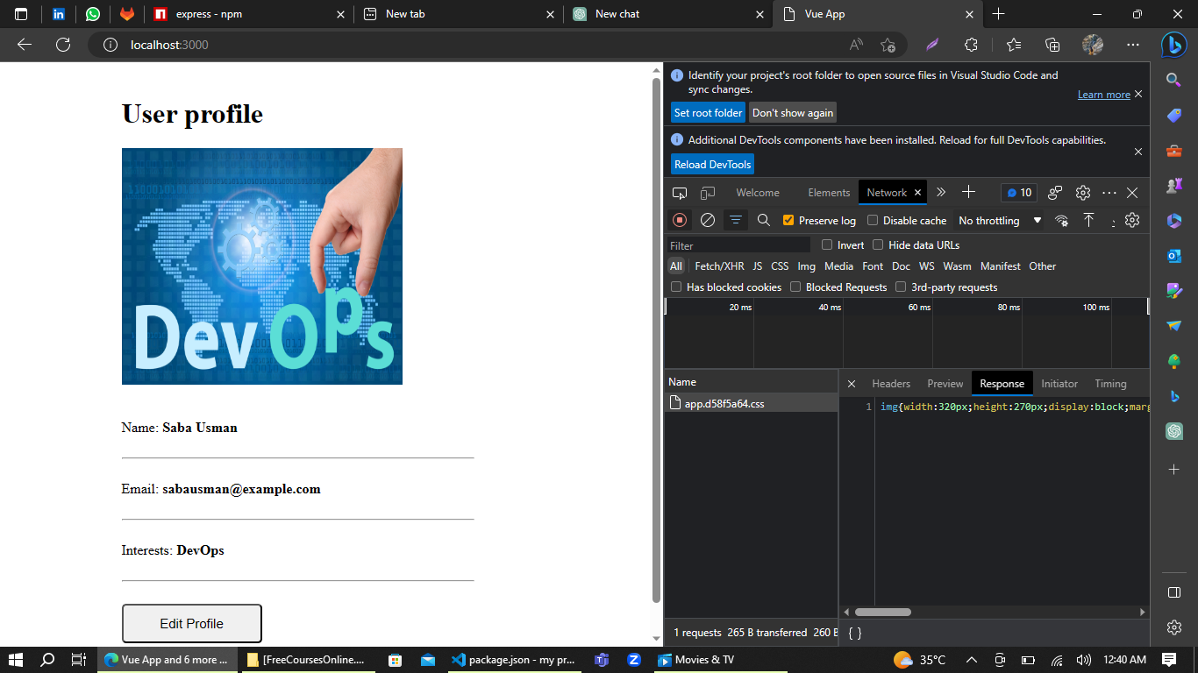

**I can't contain my excitement as I announce the successful deployment of my application, running flawlessly on localhost at the standard port 3000!**

Running the application on localhost at port 3000 allows me to test and refine its functionality before it reaches a broader audience. This local environment serves as a playground where I can experiment, make improvements, and ensure that everything is functioning flawlessly. It's a significant milestone that brings me one step closer to launching my application to the world.

**"Embarking on an Exciting Back-End Adventure!"**

Having successfully built the front-end of my application,

Next task, I have been working on the backend of my application. I am using the JavaScript framework Node.js with a server.js file, and I am pleased to share that I have successfully established the connection between the backend and the frontend of my application.

In my application, I have implemented the functionality for the frontend to send requests to the backend, and the backend is responding accordingly.

For start backend using command “node server.js”

However, there is a crucial component missing in my app, which is the database. Without a database, the data from the requests and responses cannot be properly stored and managed.

To address this issue, I need to integrate a suitable database into my application. A database will allow me to persistently store data and ensure its availability for future use. By establishing a connection between the backend and the database, I can enhance my application's functionality and enable data storage, retrieval, and management.

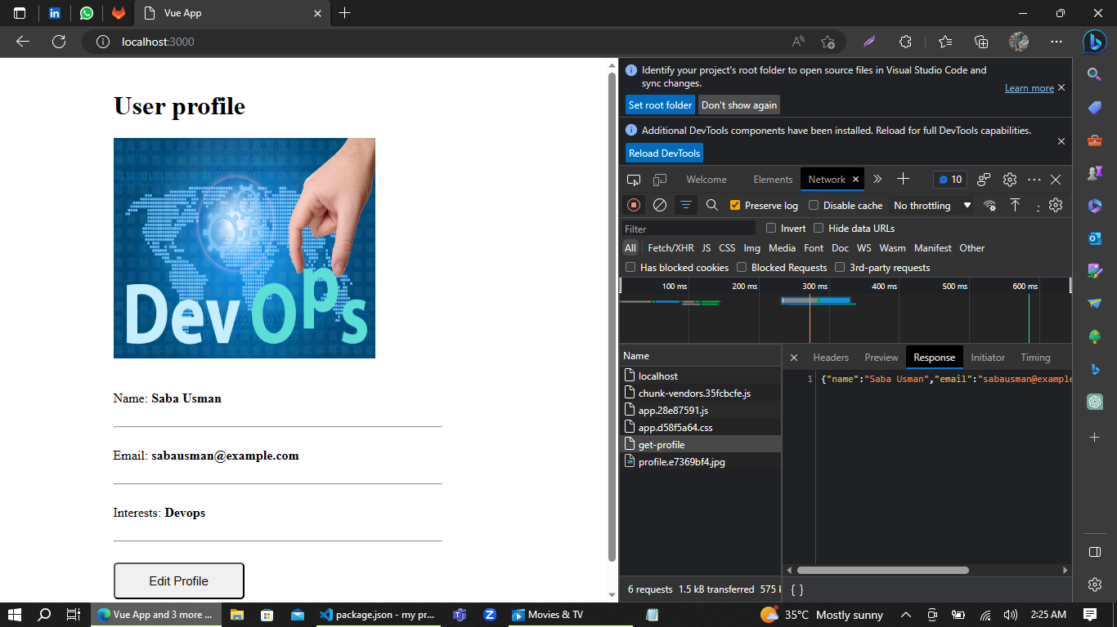

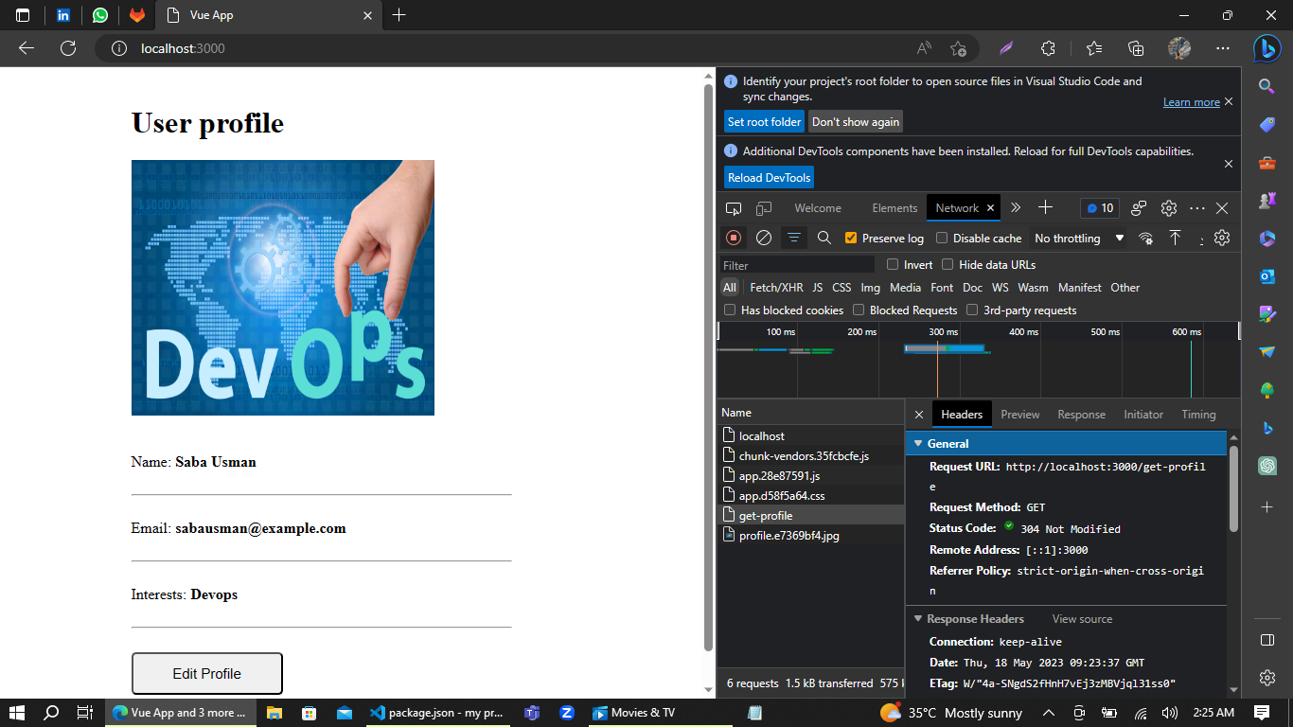

**Connecting backend to database**

The next step is to install MongoDB Compass and the Mongo shell to connect the backend to the database. I have chosen MongoDB as the database system because it is easy to manage and is classified as a NoSQL database, which means there is no need for a predefined schema.

As beginners, I think it is a suitable option.

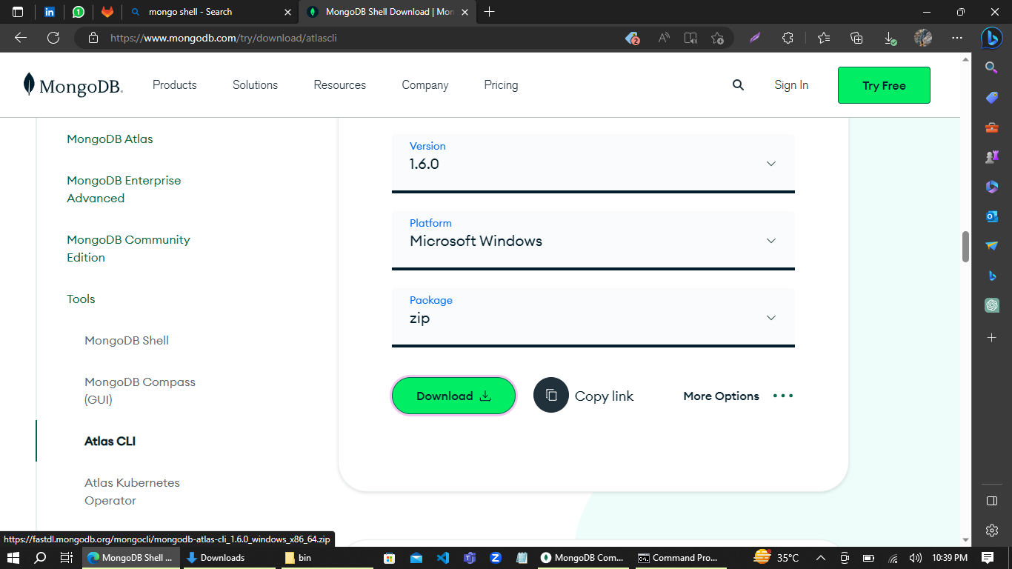

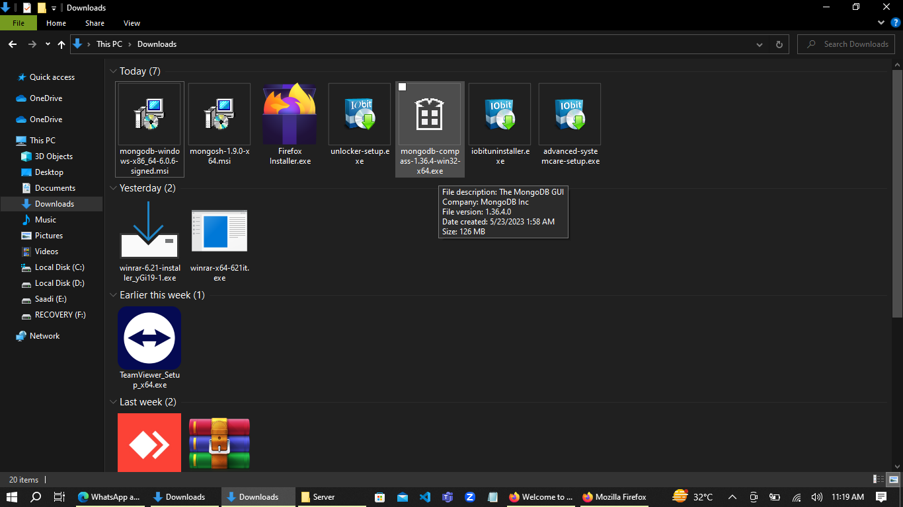

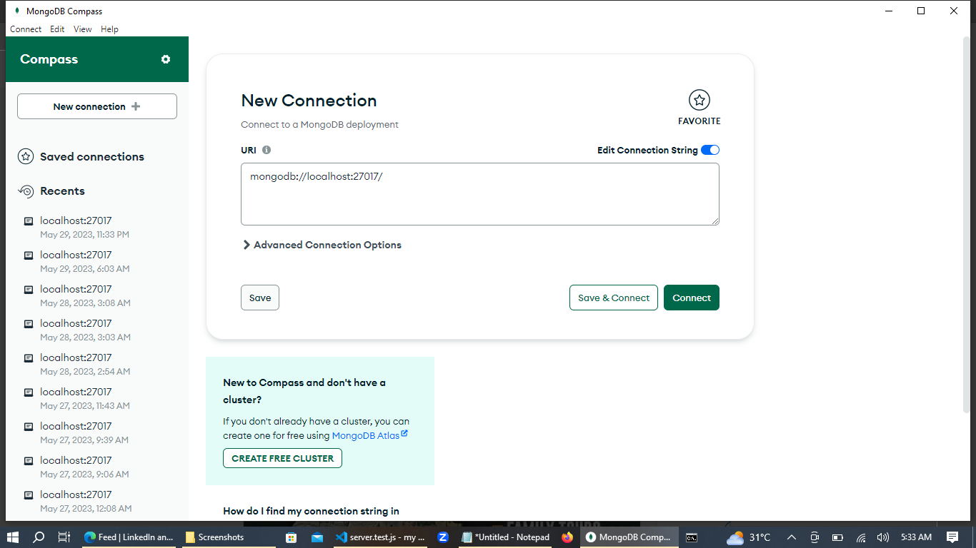

**Facing Errors**

Undoubtedly, I encountered errors while attempting to connect mongod and mongosh through the terminal.

However, after facing numerous challenges and investing significant effort, I finally managed to resolve the issue entirely on my own, without seeking any external assistance. Yahoo! This is, indeed, my true achievement.

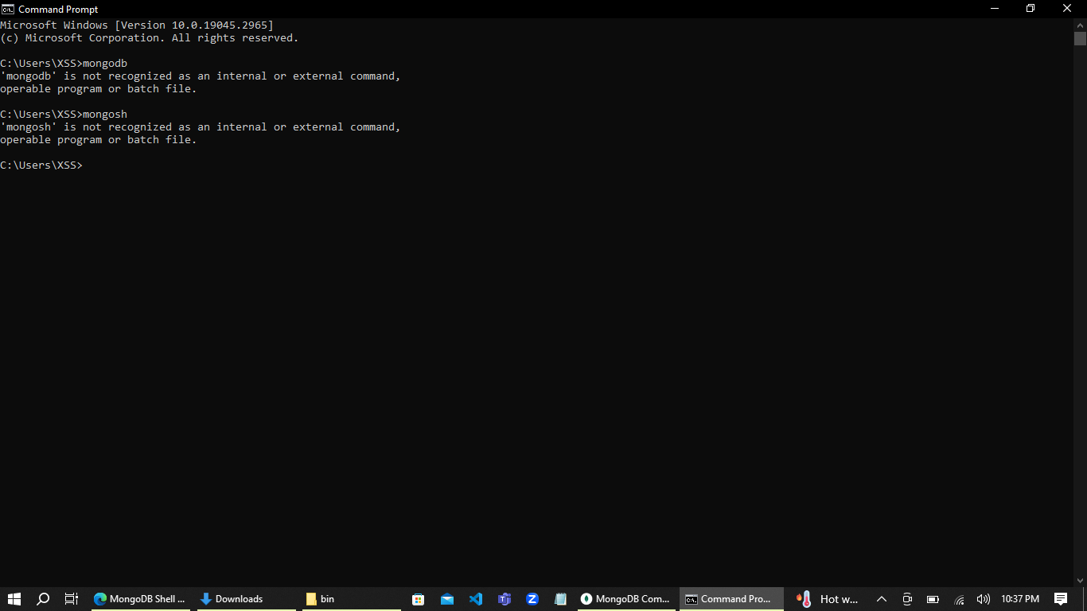

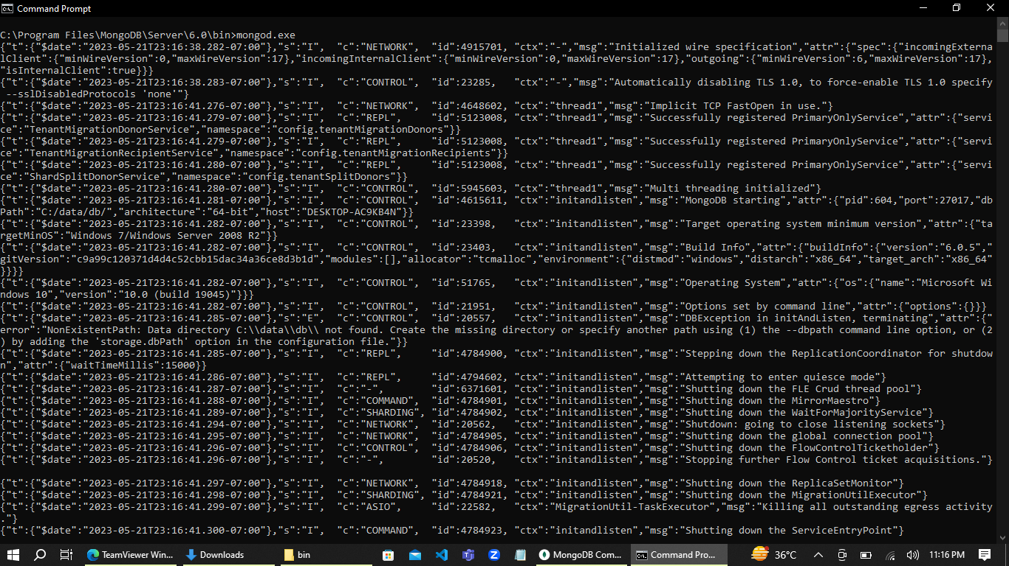

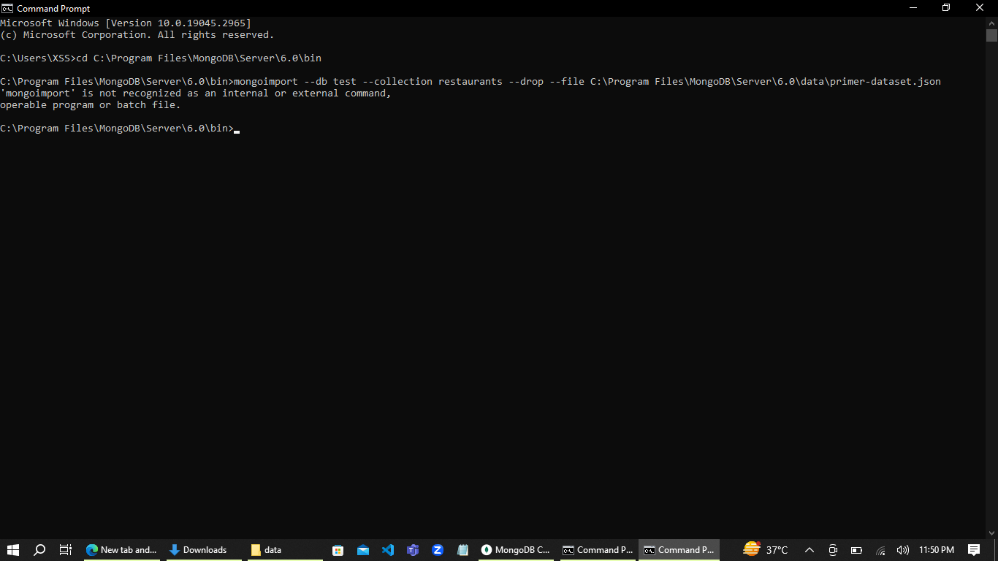

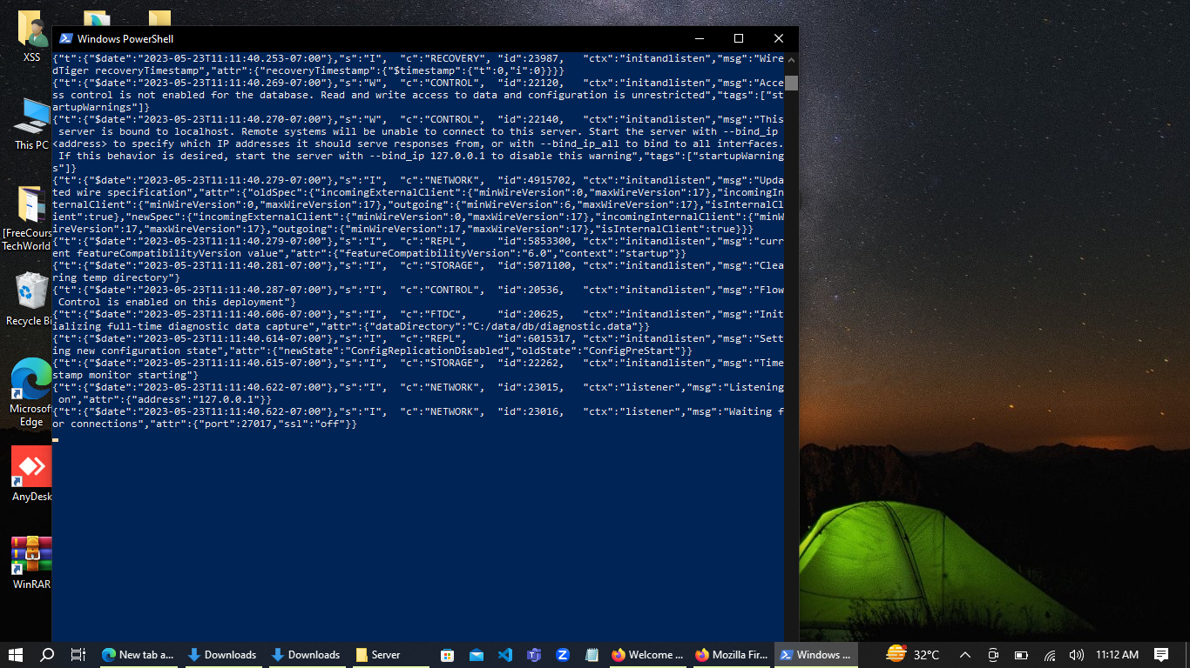

After investing a significant amount of time and effort, I finally managed to resolve the issue and successfully run mongod and mongosh on the terminal. It's time to celebrate and revel in the happiness that comes as a reward for all my hard work. Yahoo!

**Issue Resolved**

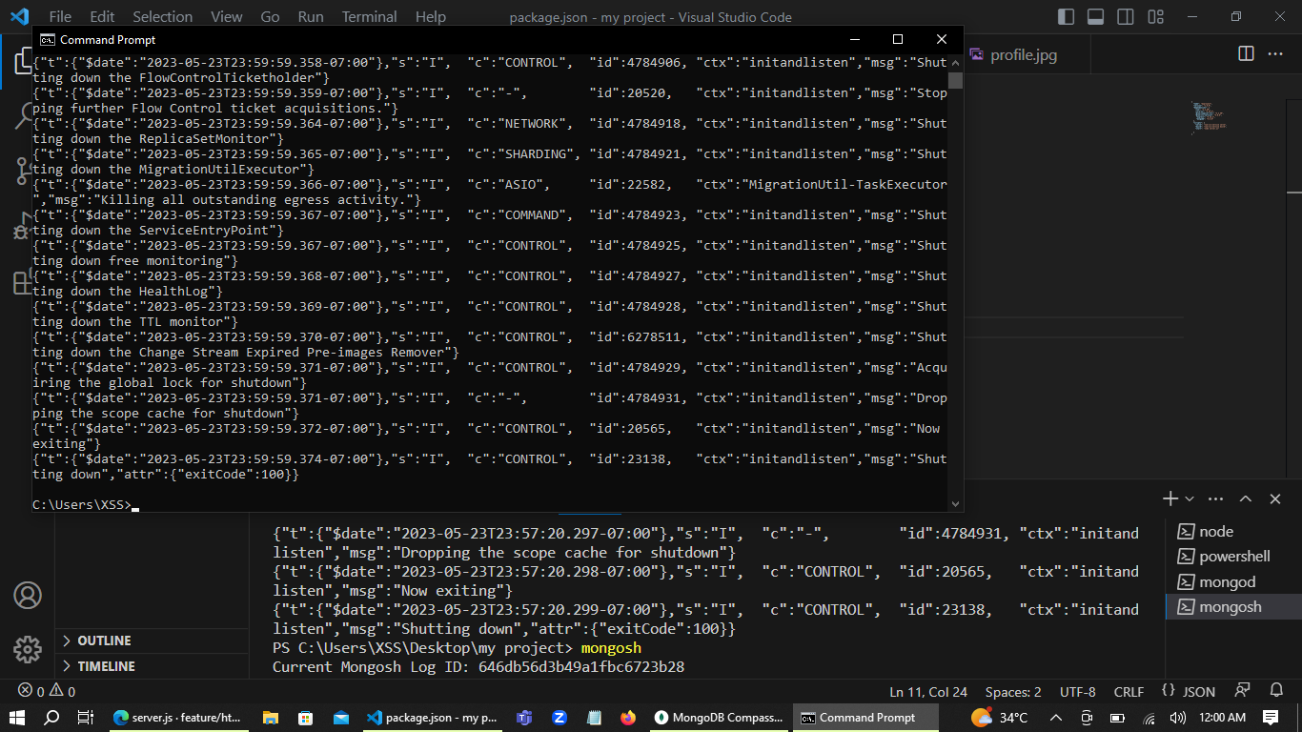

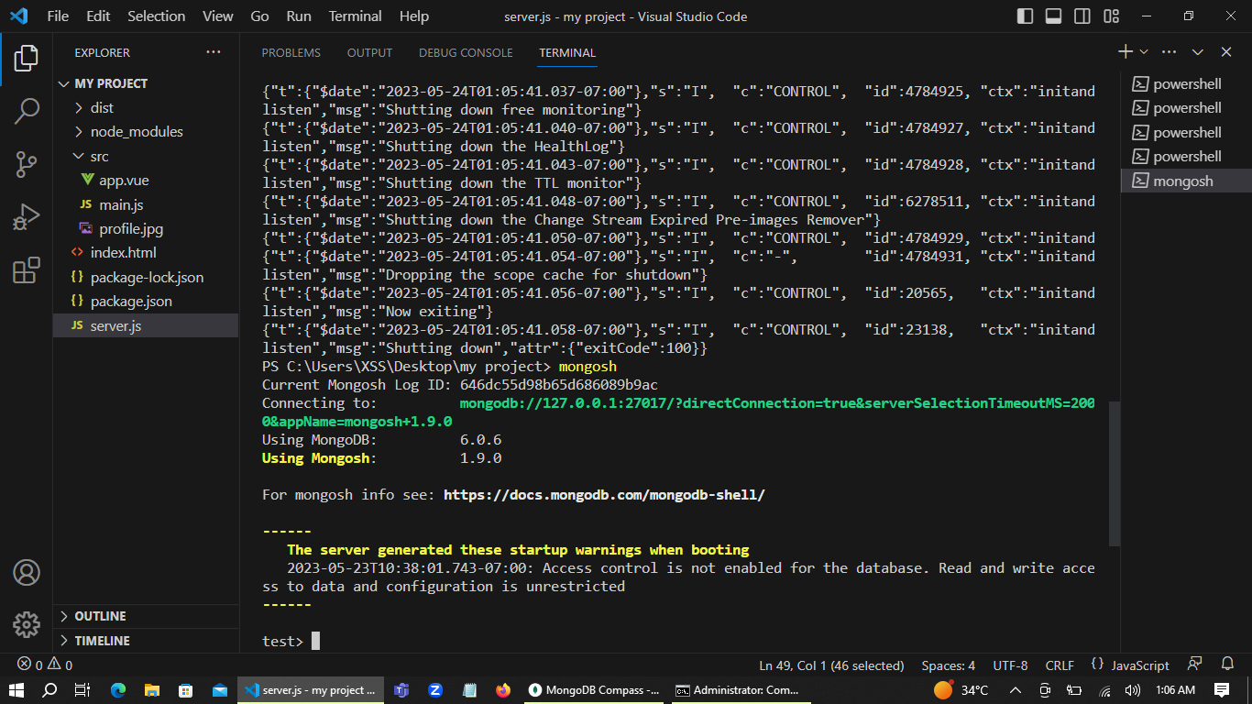

**npm run build** is a command used in JavaScript projects with npm as a build tool. It executes a predefined script specified in the project's **package.json** file, typically used to compile, bundle, and optimize source code for production deployment.

I utilize the 'npm run build' command to compile and prepare my front-end code for deployment on a server.

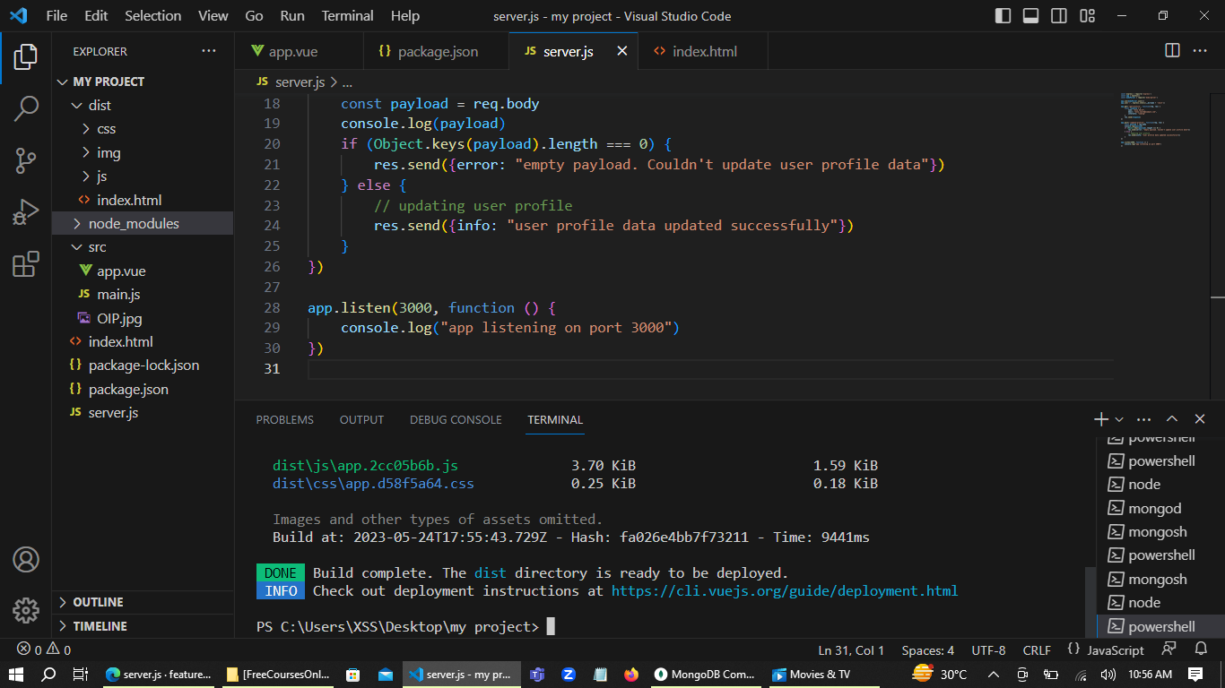

In order to address size and quality concerns, I am modifying the images during the backend integration with MongoDB.

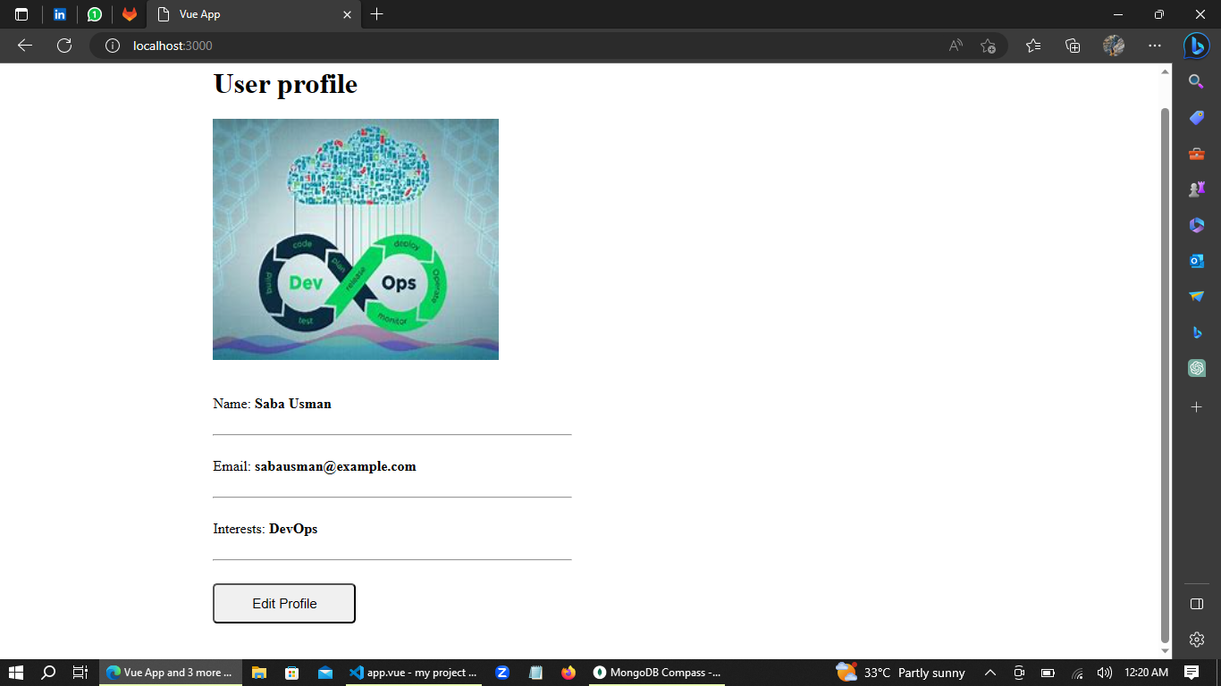

***Backend-MongoDB Integration and Data Storage;***

After successfully establishing a connection between the backend and MongoDB, whenever a web client sends a request to the backend, the backend processes the request and saves the corresponding data into the database.

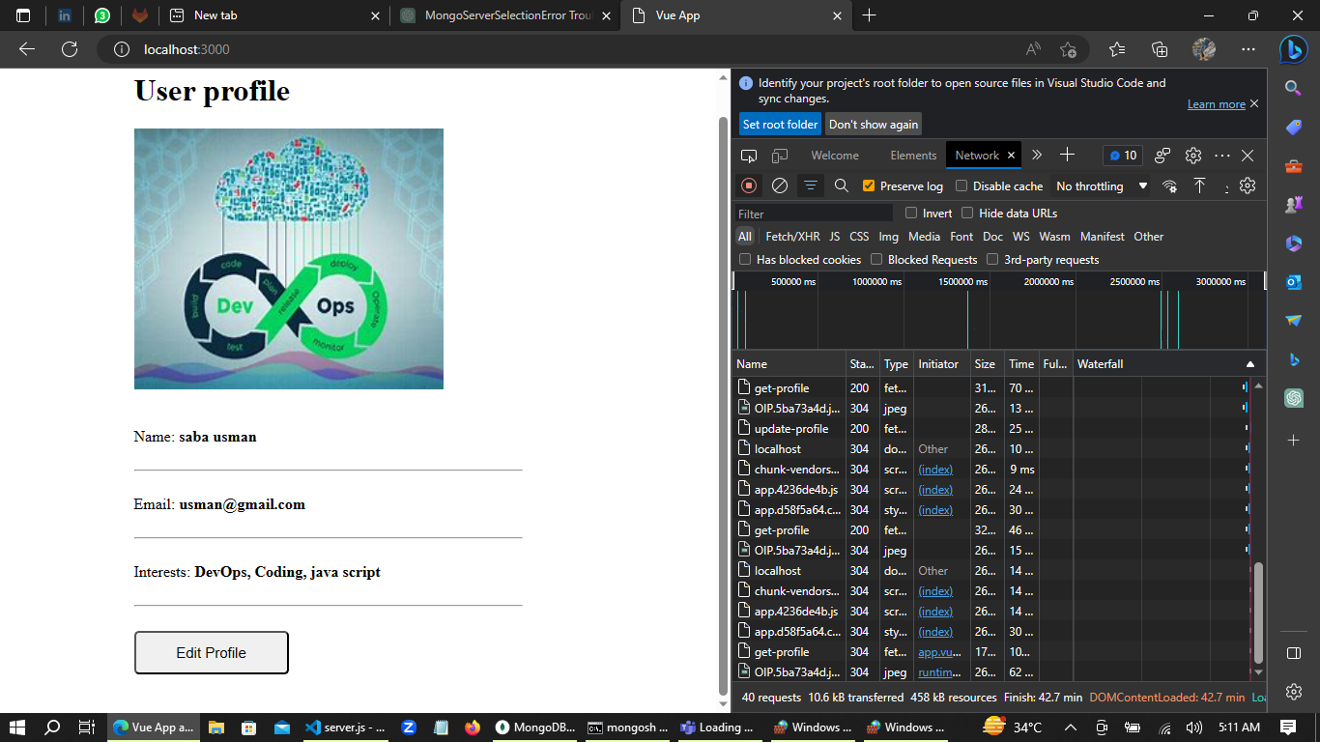

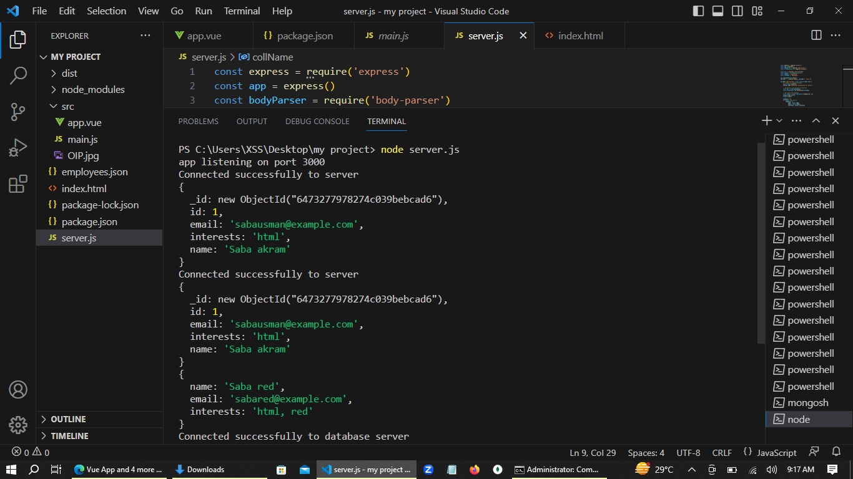

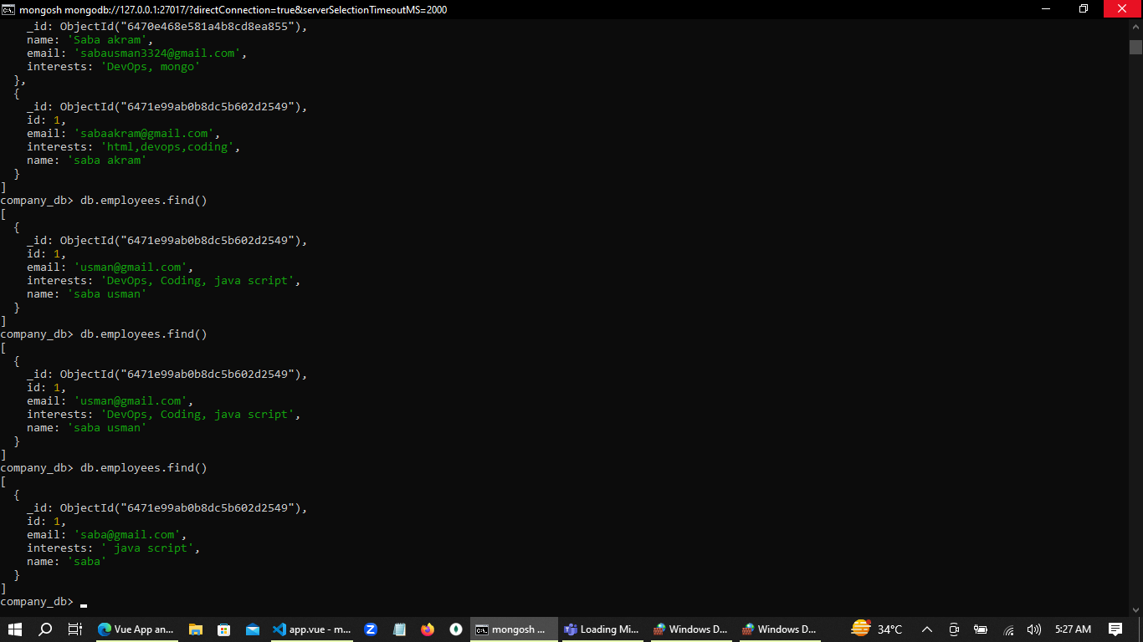

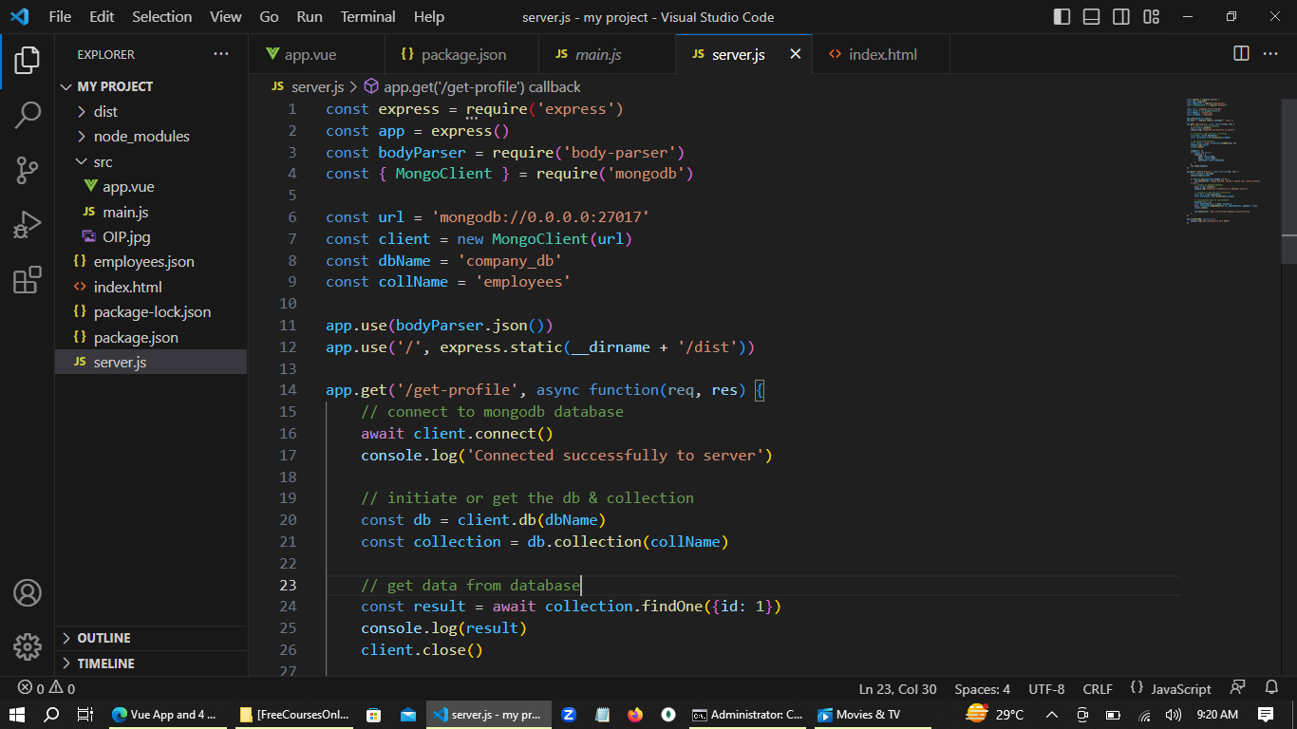

***Setting Up Dependencies and Running Unit/integration/Performance Tests;***

The next task is to add the dependencies jest and supertest in the package.json file and then install them using the command "npm install".

Write unit & automated test in my project. For test checking use command “npm run test”

**Unit test pass**

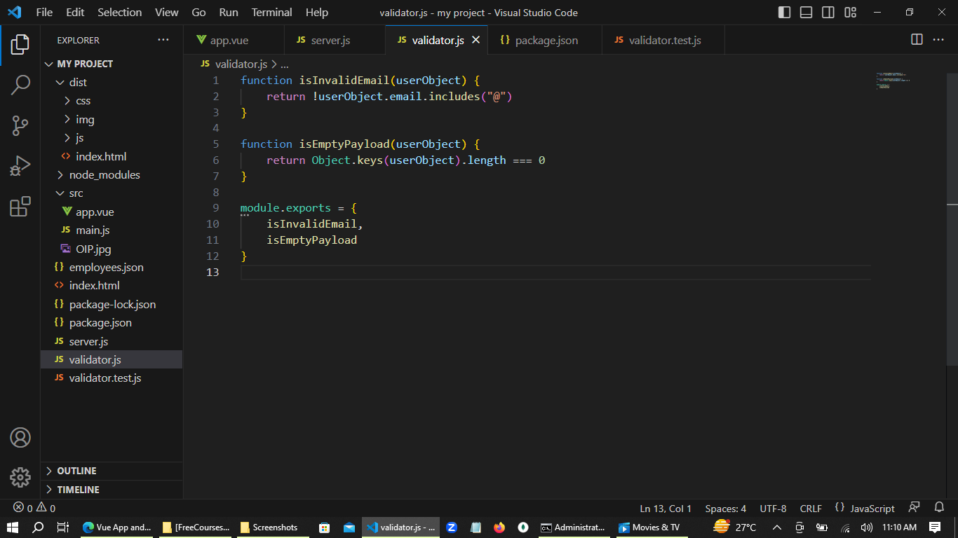

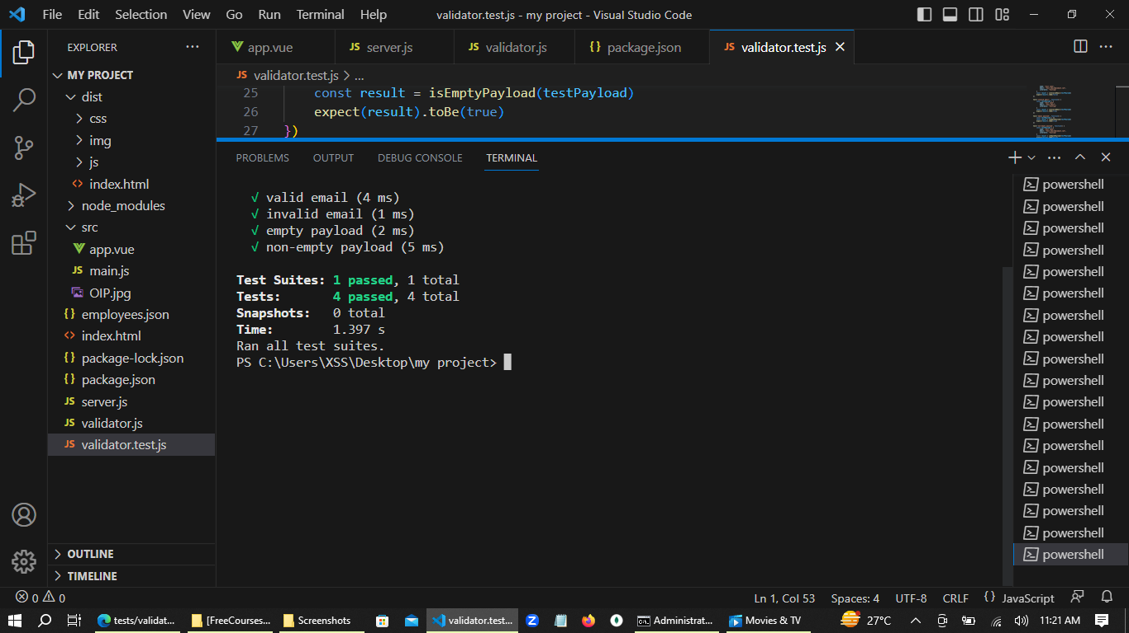

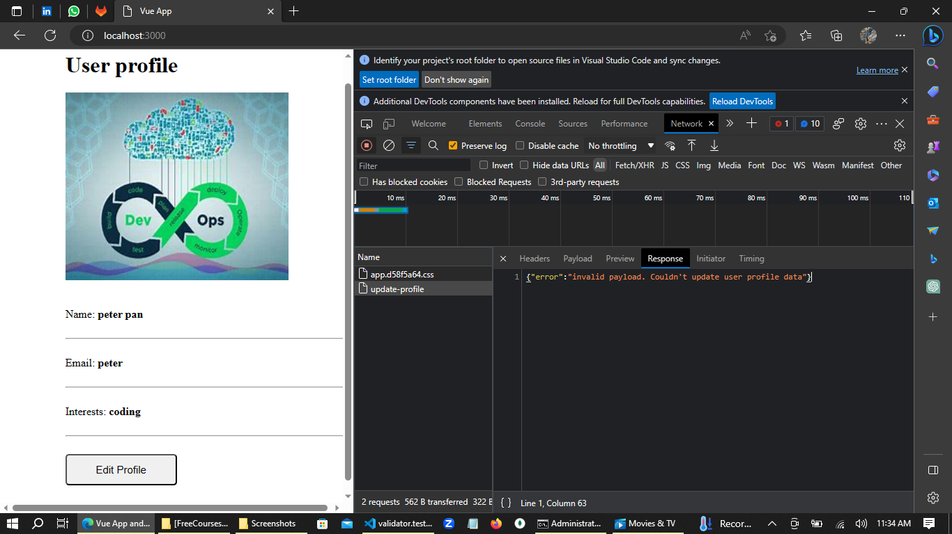

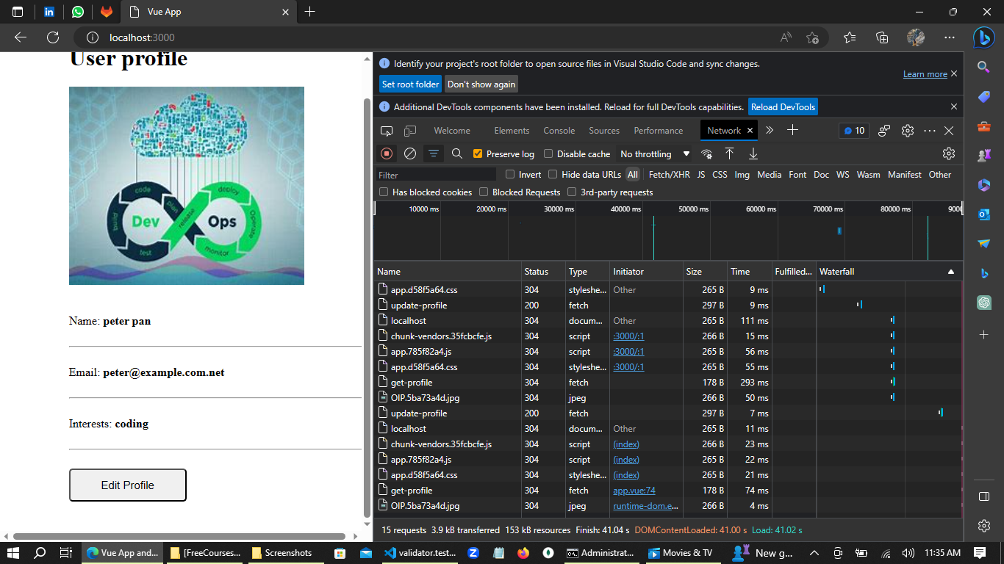

I wanted to share a recent experience I had while testing the performance of my app. I encountered a frustrating error where my app was already listening on port 3000, causing my [#integration](https://www.linkedin.com/feed/hashtag/?keywords=integration&highlightedUpdateUrns=urn%3Ali%3Aactivity%3A7069228837611462656) test to fail.  
But instead of giving up, I took the time to [#research](https://www.linkedin.com/feed/hashtag/?keywords=research&highlightedUpdateUrns=urn%3Ali%3Aactivity%3A7069228837611462656) and resolve the error.

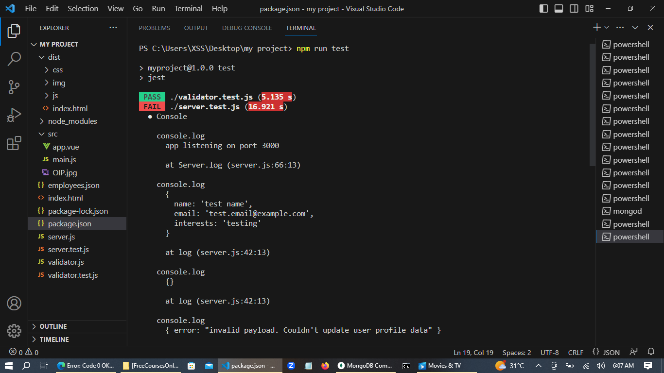

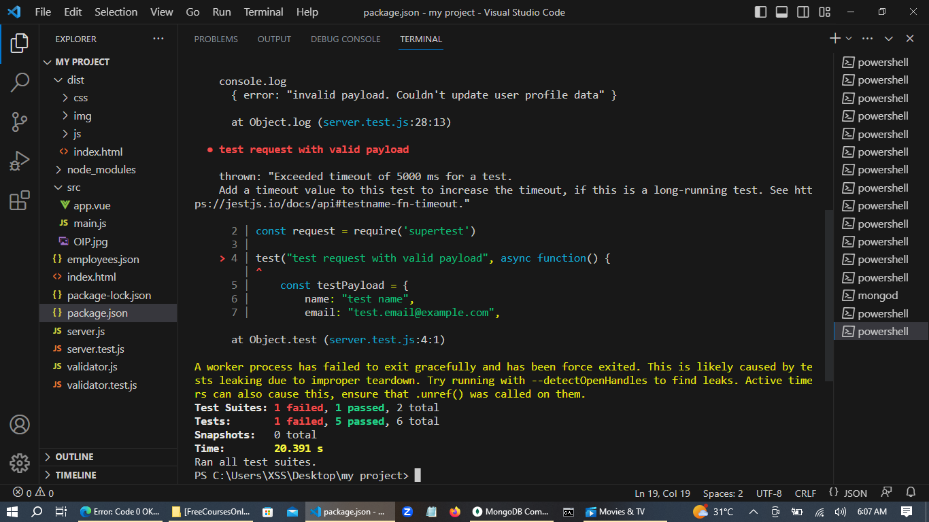

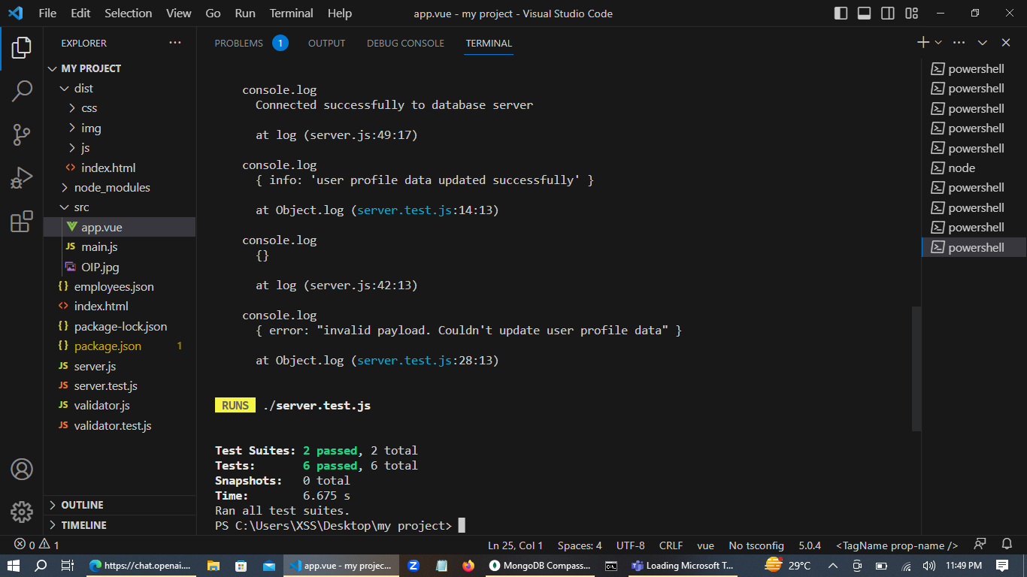

***Preparing the Project Artifact for Deployment***

I am preparing an artifact for my project using the command **npm run pack** to create a compressed package. To streamline the artifact, I use the **npmignore** extension to exclude unnecessary development files.

Moreover, I take advantage of the concept of dev dependencies in npm. Dependencies that are only necessary for development purposes but are not needed in the deployment environment are categorized as dev dependencies. By moving such dependencies into the dev dependencies section of the **package.json** file, I ensure that they are not included in the artifact, further optimizing its size and contents.

Once the artifact is ready, I can unpack it at the deployment destination. This ensures a compact and optimized deployment package for my project.

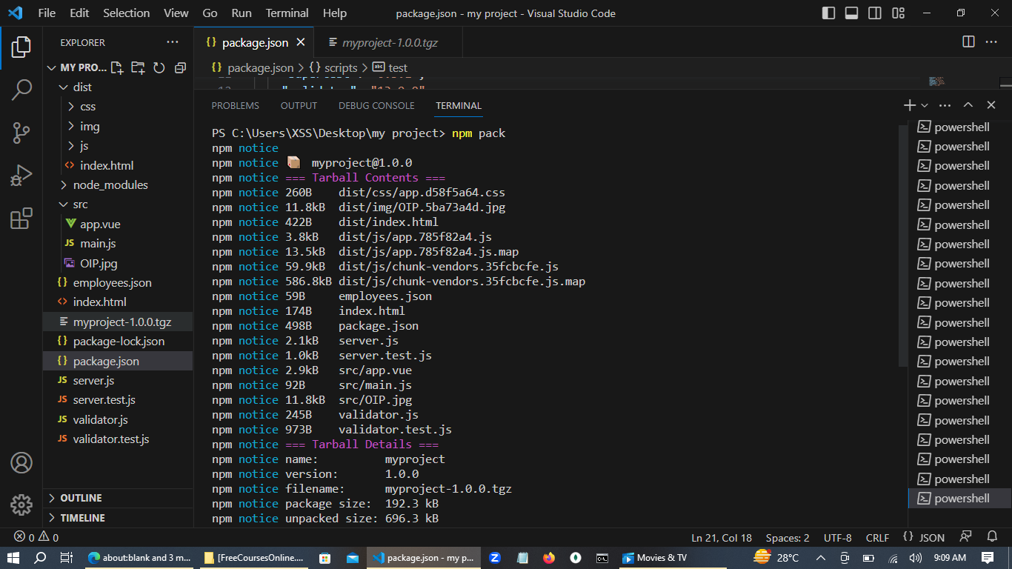

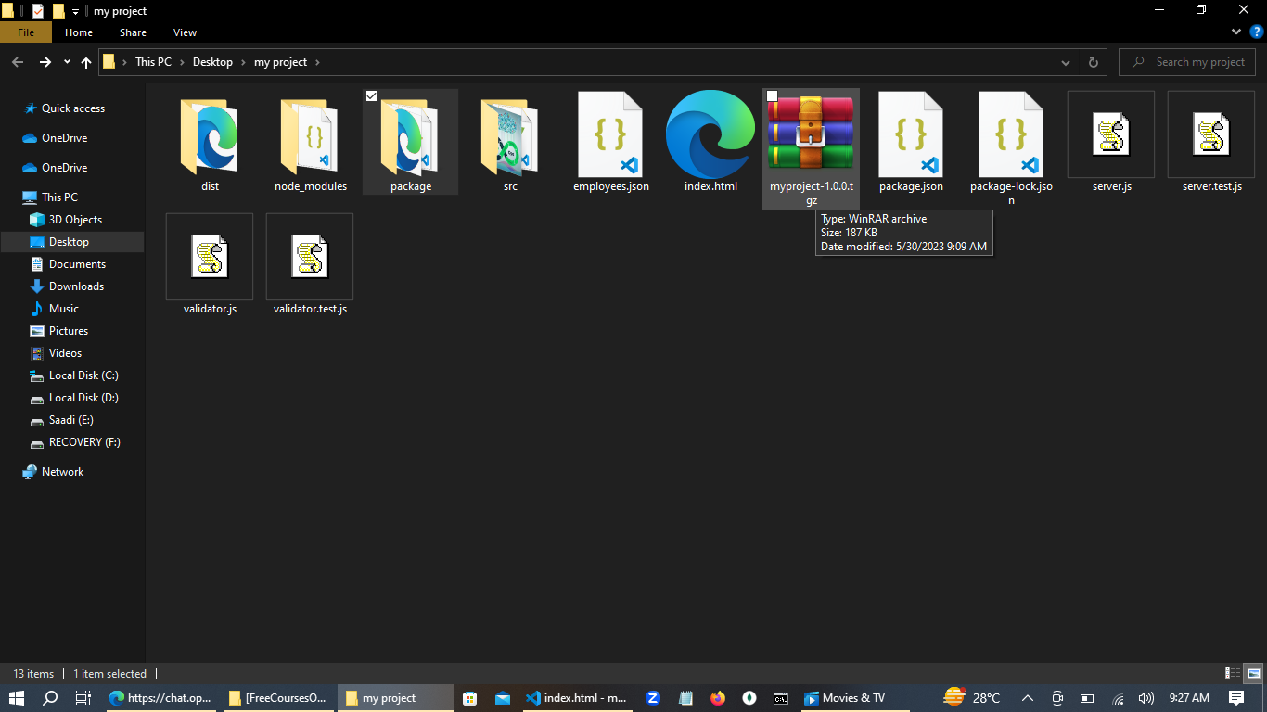

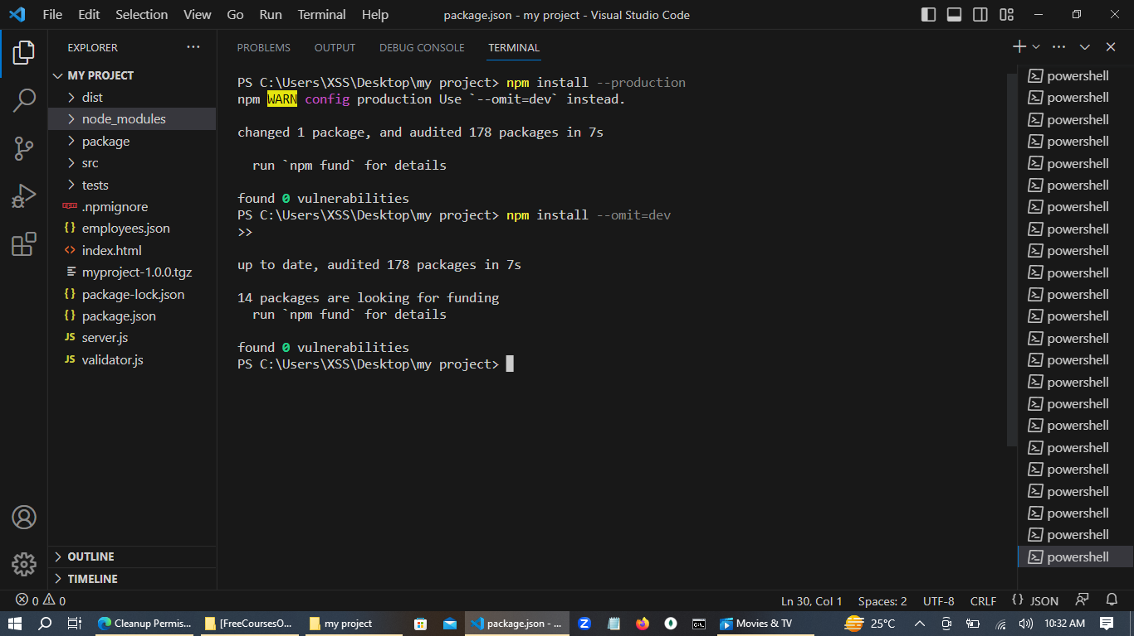

**Upcoming Plan**

 My upcoming plan to deploy an artifact on a server.   
To accomplish this, I have decided to utilize the services of Digital Ocean, a cloud provider known for its user-friendly interface and lightweight nature.  
As a beginner, I believe DigitalOcean is a suitable choice for me.   
  
Additionally, I have already downloaded and successfully connected to the server using Putty on my Windows machine.

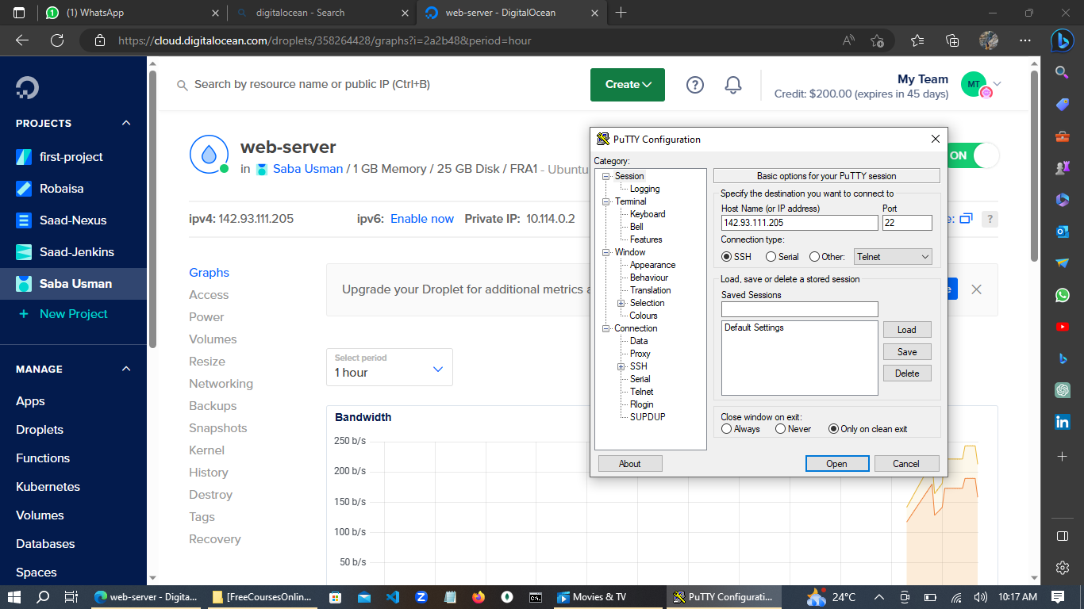

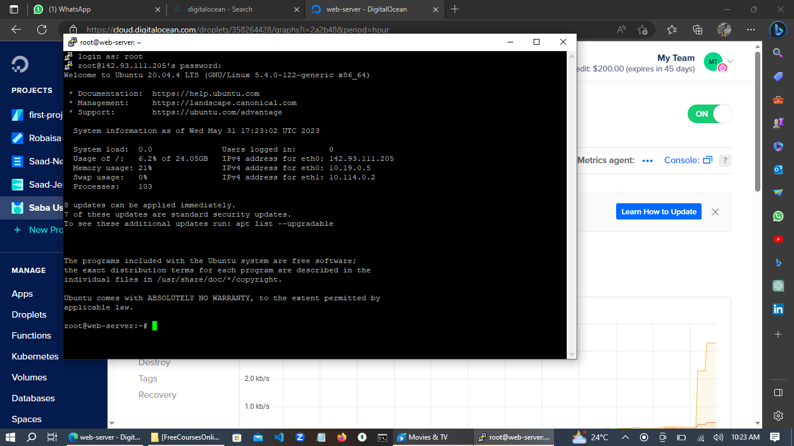

***Next Target: Configuring the Server Firewall***

**My next stop is preparing server for deployment.**

I have prepared the server for deployment. On an Ubuntu server, I installed npm and Node.js to enable running Node.js applications. MongoDB, a powerful NoSQL database, was also installed, providing efficient data storage and retrieval capabilities. To interact with MongoDB, I installed Mongosh, the MongoDB Shell. With these installations complete, the server is now ready for the deployment of my project.

**Enhancing Network Security: Managing Inbound and Outbound Firewall Rules**

Managing inbound and outbound rules in firewall is crucial for network security. Inbound rules control incoming traffic, allowing or blocking based on criteria like source IP, ports, and protocols. Outbound rules regulate outgoing connections, preventing unauthorized access and data exfiltration. Proper configuration enhances network protection and control.

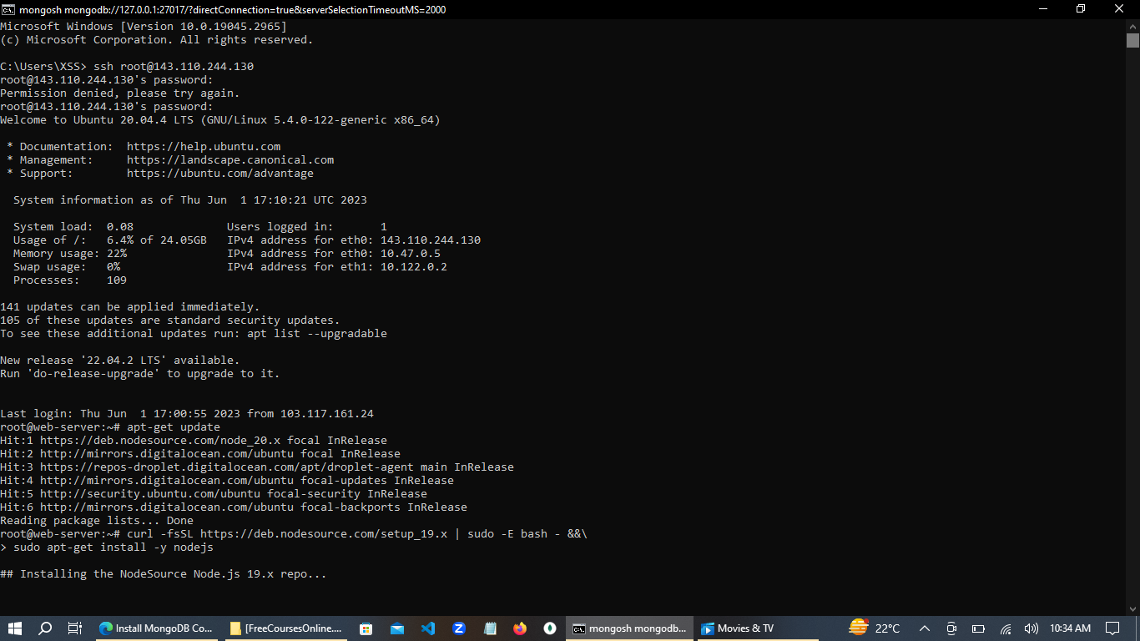

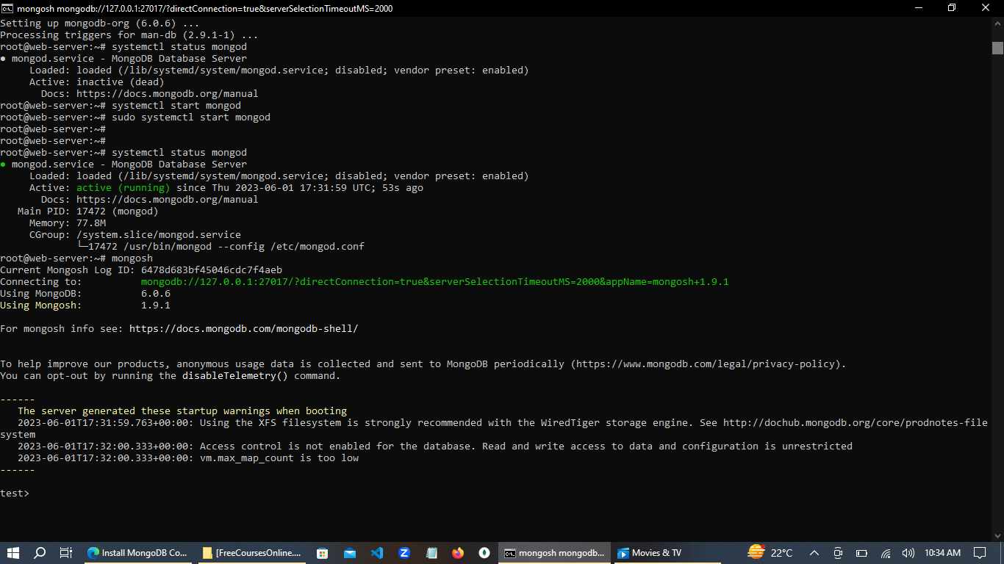

**Next stop Deployment**

Here are four simple steps to run an app on a server:

1. Prepare the app by packaging it using the command "npm pack." This command creates a tar or zip file containing the necessary files for deployment.
2. Establish an SSH connection into the remote server. SSH allows you to securely access the server's command line interface.
3. Copy the packaged artifact to the server. To transfer the tar or zip file, you can use the "scp" command followed by the file path and the destination server's address. For example, if you are logged in as the root user on the local server and want to copy the file to an Ubuntu server, the command might look like: "scp path/to/artifact.tar root@(ubuntu server address)".
4. Unpack the package file on the server using the "tar" command with the "xvf" options. For example, if the artifact file is named "myproject.tar," the command would be: "tar -xvf myproject.tar".

After unpacking, navigate to the app's directory and install the required Node.js modules using the command "npm install --omit+dev".

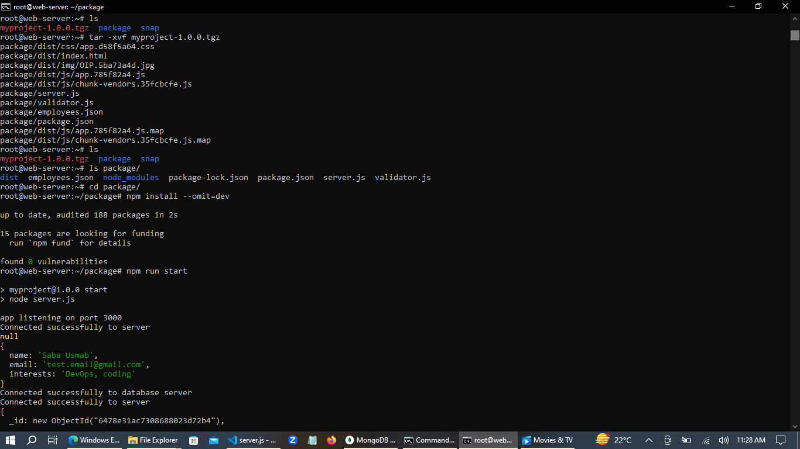

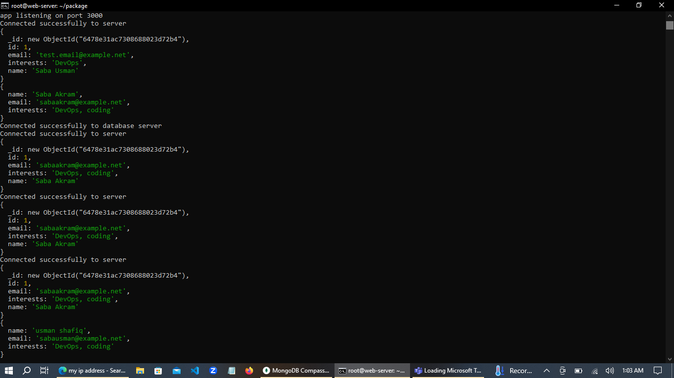

**Exciting News! Celebrating a Milestone - My App is Now Live on the Tester Server!**   
  
  
After months of hard work and overcoming various challenges, I'm thrilled to announce that my app is now up and running on the tester server! It's been quite a journey, and I've learned so much along the way. 💪  
If you're as excited as I am, go ahead and check out the app on the tester server by clicking 👇  
<https://lnkd.in/dfdzQhuY> 🌐💻

Throughout this process, I discovered that some of the obstacles I encountered were actually my own mistakes. But as they say, we learn the most from our own errors, and I am grateful for those learning opportunities. 😀💪

This project holds a special place in my heart, not only because of the hard work and dedication I put into it but also because of the immense support I received from amazing individuals like you. 🤗 Your encouragement and guidance have been instrumental in making this dream a reality.

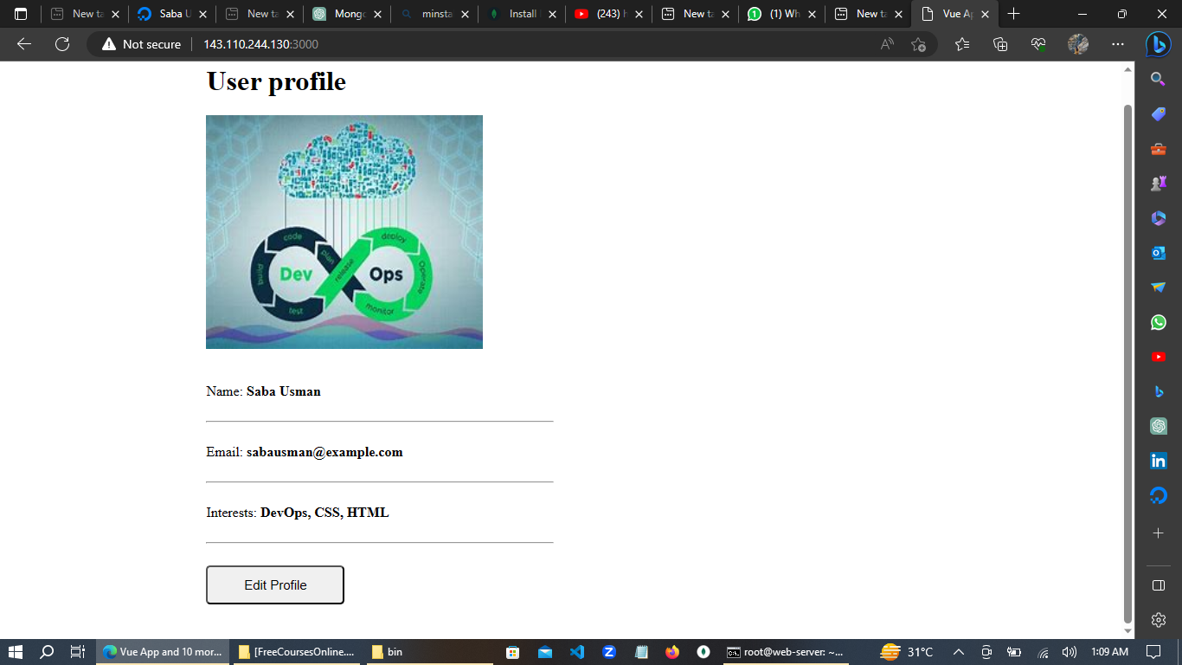

My journey doesn't end here! After completing an incredible project, I am now diving into the next phase of development, focusing on staging and production. 🎯💼 This new chapter presents exciting opportunities for growth and learning in the field I am passionate about.

Throughout this journey, I have gained invaluable skills and knowledge.

I invite you all to stay tuned and be a part of this exciting phase of my professional journey. Let's connect and stay updated on the latest developments in my field. Feel free to add me on your networks or reach out to me on LinkedIn. I am always open to connecting with like-minded professionals and sharing insights and experiences. 🤝🌐

As I move forward, I'd like to leave you with a motivational quote that has inspired me on this path:

"Success is not final, failure is not fatal: It is the courage to continue that counts." - Winston Churchill 💫

Let's embrace the challenges, learn from our experiences, and keep pushing ourselves to achieve even greater heights. Thanks everyone